**Table of Contents for the Combined Comprehensive Achievement and Civic Readiness Report and Charter School Annual Report on Prior Year Progress:**

1. Introduction ………………………………………………………………… page 3

(include school mission, vision, how the school is meeting the school’s primary and additional purposes for which it was chartered, and name and contact information of the school authorizer)

1. School Enrollment ………………………………………………………… page 4
2. Student Attrition ………..……………………………………..…………… page 7
3. Governance and Management …………………..……………..………….. page 7
4. Result of Annual Assessment of Board Performance …………………….. page 8
5. Training Each Board Member Attended in Previous Year………………… page13
6. Training Completed by the School Director ..……………..………………. page13
7. Staffing …………………………………………………………………….. page 9-10
8. Finances …………….……………………………………………………… page 11
9. Review of Goals, Outcomes, and Strategies from the Previous Year

……………………………………………………….…………………… page 14-21

(Also meets requirements for the Comprehensive Achievement and Civic Readiness Report)

1. Innovative Practices and Implementation …….………….…................... page 22
2. Improvement Plans (including for improving curriculum and instruction and cultural competency) Leading to Comprehensive Achievement and Civic Readiness …………………………………………………...…………. page 21

(Also meets requirements for the Comprehensive Achievement and Civic Readiness Report)

1. Efforts to Equitably Distribute Diverse, Effective, and In-field Teachers ….……………………………………………………………………….… page 23

(Also meets requirements for the Comprehensive Achievement and Civic Readiness Report)

1. Documentation of dissemination of information about the school’s offering and enrollment procedures to diverse community groups. The dissemination of information must be to families that reflect the diversity of Minnesota’s population and targeted groups. The targeted groups include students of color, at risk of academic failure, and underrepresented relative to Minnesota’s population, as well as families and communities identified as low-income.
2. Future Plans …………………………………….………………………… page 23

(You may want to attach your Long-Term Strategic Plan)

**Star of the North Academy**

**Independent Charter School District #4224**

**Comprehensive Achievement and Civic Readiness Report**

**2023-2024**

**SNA Mission:**

Star of the North Academy provides a caring, inclusive and nurturing environment, whereby qualified educators are dedicated to the success of all students. They are skilled in best teaching practices to maintain high expectations for students and to motivate and engage them in a safe learning environment.

**SNA Vision:**

Star of the North Academy’s vision is to provide an effective learning environment for the world’s future leaders, where all students learn, achieve and graduate with the ability to communicate and work successfully in a pluralistic society.

**INTRODUCTION**

This annual report is presented to Novation Educational Opportunities (NEO), Star of the North Academy’s authorizer, in fulfillment of the requirement of public charter schools set forth by the Minnesota Department of Education. It is also intended to provide information to the staff and families of Star of the North Academy, the Minnesota Department of Education, and the general public. Star of the North Academy is committed to providing a quality, student-focused educational program for all students. The staff collaboratively works to ensure that students receive a balanced education that includes academic achievement, physical growth, and social emotional learning. Individual student progress is measured and documented through formal and informal classroom assessments and used as a tool to develop instructional strategies. Achievement is reported in a variety of ways to parents and stakeholders. Star of the North Academy uses NWEA-Measures of Academic progress, the FAST Bridge (aReading and aMath standardized tests), WIDA Access Testing for ELL Students, end of the term comprehensive exams and Minnesota Comprehensive Assessments (MCAs).

**SPONSOR/AUTHORIZER INFORMATION**

Star of the North Academy is pleased to have the opportunity to function under the authorization of NEO. We look forward to many years of successful operation under their guidance and support. We have been a charter school since the 2014-2015 school year. We recognize the strong support we have received from the community that had the original vision to create our school and the many who are still with us today. We are excited to welcome all of the new families who have joined us this year and look forward to continuing to emerge as the premiere charter school of the northern suburbs. We submit this Annual Report to NEO with gratefulness and in anticipation of many productive years to come.

**SCHOOL ENROLLMENT**

In the 2023-2024 school year, there were **184** students enrolled at Star of the North Academy at the end of the school year. Students were distributed into grade level classes as follows:

**Grade Level Enrollment**

| **Grade Level** | **Number of students** | **Number of boys** | **Number of girls** |
| --- | --- | --- | --- |
| **Kindergarten** | 21 | 12 | 9 |
| **First Grade** | 29 | 14 | 15 |
| **Second Grade** | 26 | 8 | 18 |
| **Third Grade** | 19 | 12 | 7 |
| **Fourth Grade** | 22 | 8 | 14 |
| **Fifth Grade** | 18 | 8 | 10 |
| **Sixth Grade** | 16 | 8 | 8 |
| **Seventh Grade** | 17 | 10 | 7 |
| **Eighth Grade** | 16 | 6 | 10 |
| **Total** | 184 | 86 | 98 |

STUDENT DEMOGRAPHICS

As the bar graph indicates, our students reside in many different communities in the North Metro:

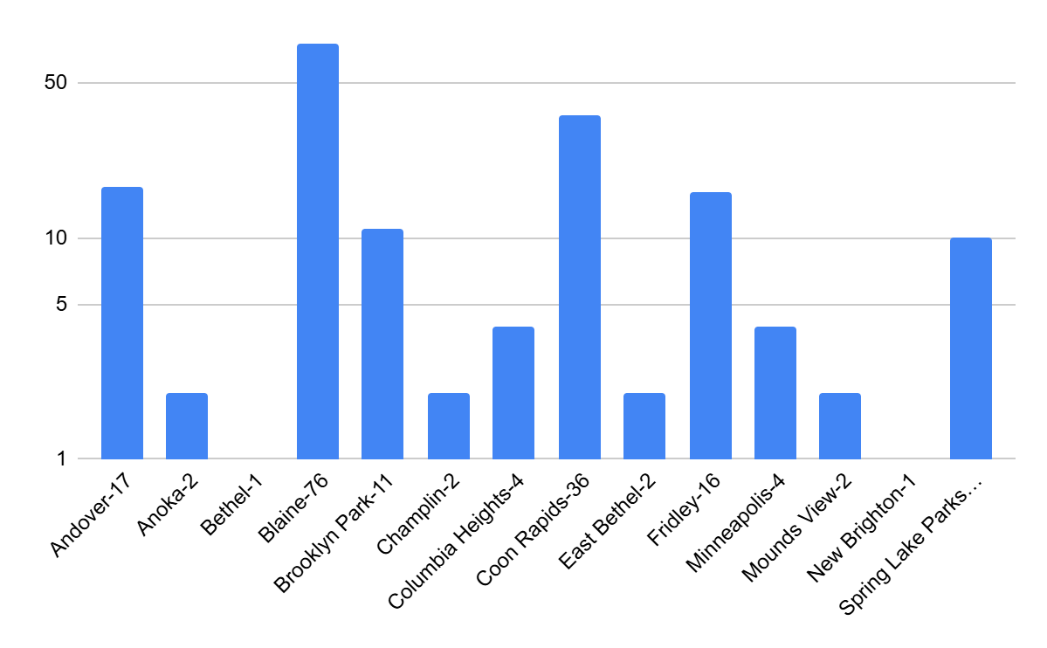

The following table provides demographic trends at the end of each year at Star of the North Academy.

| ***School Year*** | **2015-**  **2016** | **2016-**  **2017** | **2017-**  **2018** | **2018-**  **2019** | **2019-**  **2020** | **2020-**  **2021** | **2021-**  **2022** | **2022-2023** | **2023-2024** |
| --- | --- | --- | --- | --- | --- | --- | --- | --- | --- |
| Male | 82 | 86 | 74 | 74 | 63 | 62 | 72 | 82 | 98 |
| Female | 66 | 75 | 69 | 79 | 79 | 66 | 85 | 109 | 86 |
| African American | 69 | 75 | 67 | 79 | 57 | 64 | 97 | 97 | 93 |
| Hispanic | 0 | 0 | 1 | 1 | 0 | 1 | 3 | 1 | 0 |
| Asian | 26 | 24 | 26 | 24 | 29 | 22 | 28 | 33 | 34 |
| White | 53 | 62 | 49 | 49 | 40 | 39 | 47 | 60 | 59 |
| American Indian | 0 | 0 | 0 | 0 | 0 | 0 | 0 | 0 | 0 |
| Free & Reduced Meals | 94 | 120 | 94 | 122 | 100 | 98 | 115 | 134 | F: 169  R: 15 |

| Multilingual Learners | 40 | 51 | 48 | 49 | 45 | 43 | 48 | 56 | 80 |
| --- | --- | --- | --- | --- | --- | --- | --- | --- | --- |
| Special Education | 1 | 4 | 11 | 16 | 11 | 7 | 13 | 20 | 18 |
| End of Year Total  Enrollment | 148 | 161 | 143 | 153 | 142 | 128 | 157 | 191 | 184 |

**STUDENT ATTRITION**

The year ended with 184 active students and 47 waitlisted. We were unable to accommodate the students who were on the waiting list because the school reached its capacity. In the 10 years of operation, our student enrollment has fluctuated between 153 and 200 students.

**GOVERNANCE AND MANAGEMENT**

**School Management**

The Administrative Team in 2023 -2024 includes the Executive Director, Operations Manager, Dean of Students, and Administrative Assistant. A system of checks and balances has been established for the financial accountability of the school. The School was in a good financial status for the school year 2023-2024.

The Board of Directors’ primary responsibility is to provide supervision of the school’s executive director and their decisions focus on all dimensions of the school’s operation, including, but not limited to:

1. School Philosophy, Goals and Objectives

2. School Policy

3. Finances & Budget

4. Curriculum and Instructional Direction

5. Staffing

6. Strategic Planning

7. Communication (home, community, authorizer)

8. School Enrollment and Organization

The Star of the North Academy’s Board of Directors consists of the following voting members:

1. 1 licensed teacher representative

2. 1 parent representative

3. 3 community representatives (Community Members Majority)

4. One Ex-Officio member: school executive director

5. **5 voting members total**

The members of the Board of Directors serve 5 year renewable terms, with board elections taking place in May. In May of 2023, the school board held its election for the upcoming term. The 3 incumbent members were re-elected.

The Board of Directors meets on the third Thursday of the month. Special meeting days and times, as determined by the Board of Directors, are publicly posted and announced to parents, staff, and community.

**2023- 2024 Board of Directors**

| Javed  Mohammad | jmohmmad@snacharterschool.org | Board Chair | Community | 6/30/23 - 06/30/27 |
| --- | --- | --- | --- | --- |
| Abdul Khadeer | Akhadeer@snacharterschool.org | Member | Community | 6/30/23 06/30/27 |
| Natoli Umer | naatumer@gmail.com | Member | Community | 6/30/23-  6/30/27 |
| Fikret  Ajdinovic | fiko75@msn.com | Member | Parent | 11/21/23 - 6/30/27 |
| Zeenat Ahmed | zeenat22@snacharterschool.org | Member | Licensed  Teacher | 11/21/23-  6/30/27 |

**STAFFING**

CERTIFIED STAFF

| **Grade Level** | **File/Folder #** | **Position** | **Years of experience** |
| --- | --- | --- | --- |
| Kindergarten | 1032696 | KG teacher | 1 |
| First Grade | 1029155 | 1st grade teacher | 1 |
| Second Grade | 1022309 | 2rd grade teacher | 2 |
| Third Grade | 1012681 | 3rd grade teacher | 2 |
| Fourth Grade | 394398 | 4th grade teacher | 10 |
| Math Teacher | 322288 | MS (5 -8th) Math | 1 |
| Science Teacher | 1028241 | MS (5th-8th) Science | 1 |
| ELA Teacher | 1027839 | MS (5th-8th) ELA | 10 |
| Social Studies Teacher | 1027834 | MS (5th-8th) Social Studies | 7 |
| ELL Teacher | 514759 | Multiple Language Learner | 7 |
| PE Teacher | 1027746 | PE | 1 |
| World Language Teacher | 1024186 | World Language | 7 |
| Special Education Teacher | 1028055 | Special Education | 1 |
| Dean of Students | 502560 | Dean of Students | 4 |
| Special Education | 1020014 | Special Education | 8 |
| Building Substitute | 1022004 | Short Term Sub | 2 |

NON-CERTIFIED STAFF

| Dempartment | Position | Year of Experience |
| --- | --- | --- |
| Administration | Executive Director | 3 |
| Administration | Operations Manager | 1 |
| Administration Team | Admin Assistant | 4 |
| First Grade | General Ed. Para | 3 |
| SpEd Dep. | SPED Para | 2 |
| SpEd Dep. | SPED Para | 4 |
| SpEd Dep. | SPED Para | 2 |
| Support Team | General Ed. Para | 1 |
| Support Team | General Ed. Para | 1 |
| Intervention | General Ed. Para | 1 |

**Staff In-Service Training and Ongoing Development**

This framework created the structure for in-service PD training and the on-going PD training offered throughout the school year. During the August in-service weeks, we focused on building a strong school community, analyzing data, and the implementation of best instructional practice to move our academic performance forward. Staff Professional Development training included:

· Wonders Reading Curriculum Training

· Pacing Guide & Curriculum Mapping

· Lesson Planning & Gradual Release of Responsibility

· Guided Reading

· Benchmark ELA & Math Expressions training,

· Team Building

· Social and Emotional Learning,

· Special Education Modifications

· Engaging with families and students

**FINANCES**

Creative Planning provides financial services for Star of the North Academy since February of 2023.

Star of the North was able to secure several new grants in FY24, including Come Teach MN, REAP, The University of St. Thomas Teacher grant, food service equipment grants and several grants that will stretch into FY25. They approved a positive net income on the Original and Revised budgets for FY24. Revenues and expenditures were both over budgeted amounts and we ended the year with a profit of $230,734, which resulted in a fund balance of $746,307 as of June 30, 2024. This brought our fund balance percentage of expenditures to 21%, an improvement over prior year of 4%.

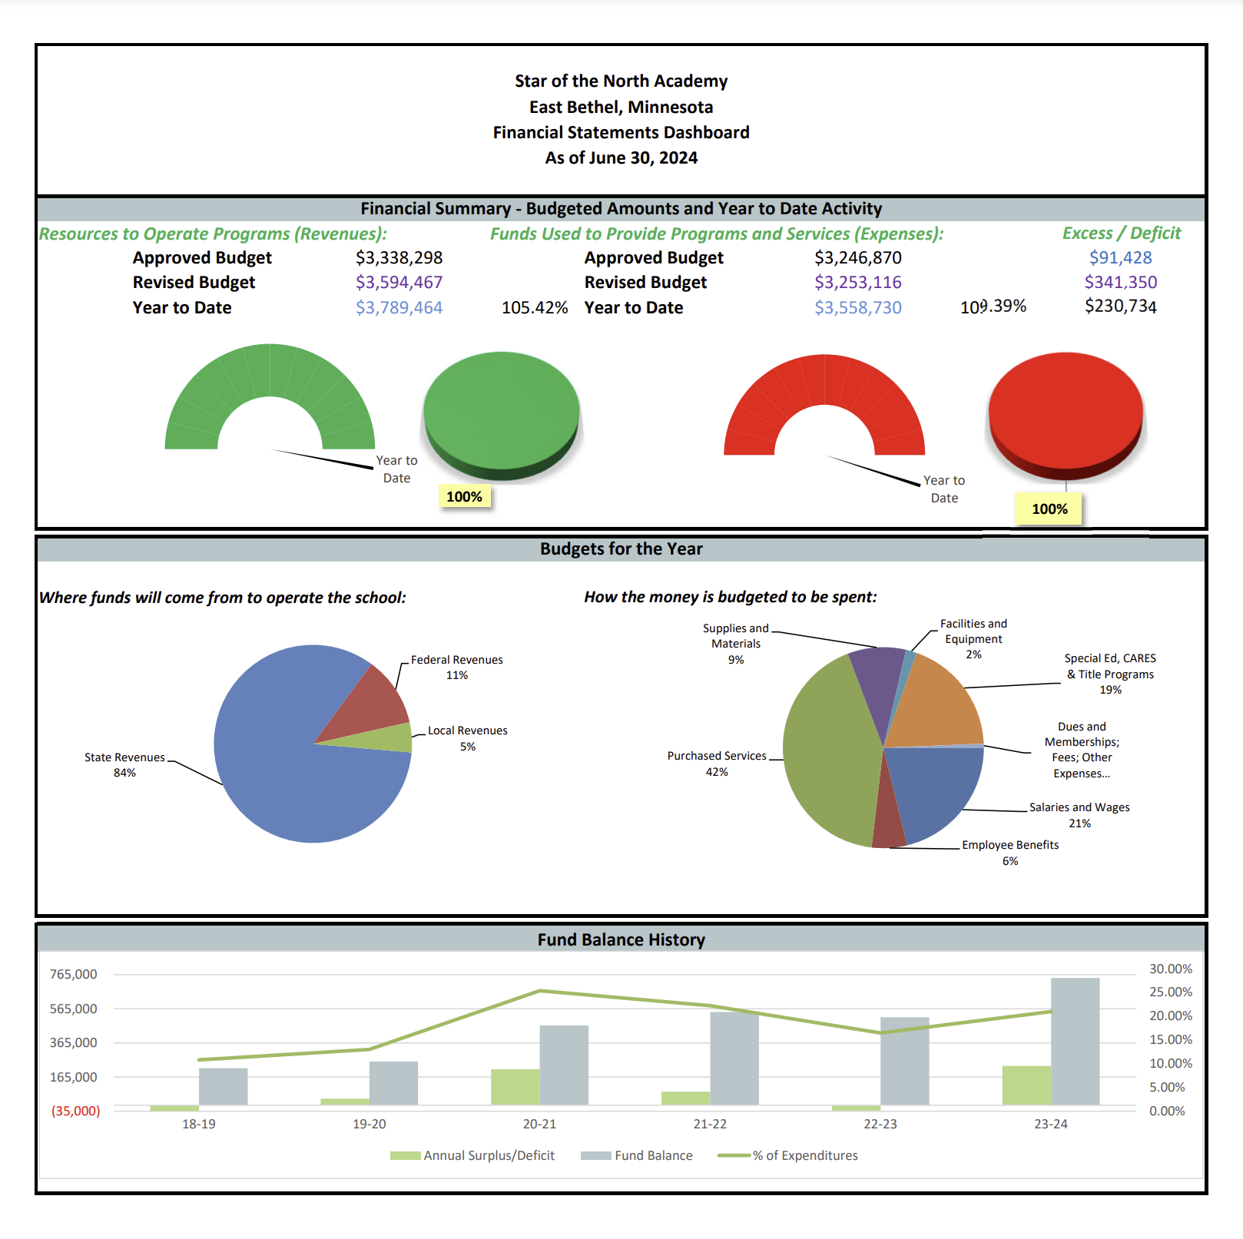

**BOARD TRAINING**

The SNA school board received the following board training during the 2023-2024 school year

| **Date** | **Topic** |
| --- | --- |
| **November 17, 2023** | **Conflict of Interest Board training** |
| **March 19, 2024** | **Board Training: Conduct Financial Oversight of Cash Flow** |

**EXECUTIVE DIRECTOR’S PROFESSIONAL DEVELOPMENT PLAN**

Ms. Eman Ibrahim, the executive director, has worked in different charter and public schools and in different capacities to create learning environments where the learning needs of each individual child can be met. Through rigorous instruction, the use of data to increase student growth and by developing highly skilled teachers, she has been able to provide families with viable learning options for their children.

**This past year, the executive director professional development plan included the following:**

Weekly meetings with SPS executive director who provides intensive training and support

Novation Education Opportunities Learning & Leading Events

**MDE Sessions:**

MDE sessions for schools on MEGS and Title Funding

MDE Session about Assessment and MAP Reports

Family Engagement Series Session

**Academic Performance, including Student Achievement Goals and Success in Realizing the Goals and Related Benchmarks, and Local Assessment Outcomes:**

### ***I. All Children are Ready for School***

### Early Literacy and Numeracy Goals for Kindergarten

The school has set two Early Literacy and Numeracy goals aimed at improving the foundational academic skills of Kindergarten students. These goals are critical to ensuring that students are well-prepared for future learning and success.

#### **Numeracy Goal**

* **Goal**: 80% of Kindergarten students will be at or above the 60th growth percentile in early numeracy.
  + **Progress**: The school has achieved significant progress in this area, with the percentage of students meeting the target increasing from **66.67% to 80.95%**. This is an exemplary achievement, indicating that early numeracy skills are being effectively developed in Kindergarten students.
  + **Analysis**: The school has made commendable strides in improving early numeracy, and the goal has been met with an exemplary rating. This progress is a positive indicator of the school's success in supporting early mathematical development.

#### **Literacy Goal**

* **Goal**: 80% of Kindergarten students will be at or above the 60th growth percentile in early literacy.
  + **Progress**: Unfortunately, the school has experienced a decline in early literacy performance, with the percentage of students meeting the target decreasing from **53.45% to 47.62%**. This decline highlights the need for focused interventions in early literacy to support students' reading and language development.
  + **Analysis**: While numeracy performance has shown strong growth, the drop in literacy performance suggests a gap that needs to be addressed. Targeted interventions and instructional adjustments are necessary to improve early literacy outcomes and ensure that all students are prepared for continued academic success.

### **Conclusion**

The school has made excellent progress in early numeracy, meeting the goal with an exemplary rating. However, the decline in early literacy performance must be addressed to ensure that Kindergarten students are fully prepared for school. Focused efforts and strategies to improve early literacy are essential to achieving the overall academic goals for early childhood education.

### ***II. All Students are Ready for Career and College***

### Attain Grade-Level Proficiency - State Comparison

The school has made efforts to improve academic proficiency across key subjects—math, reading, and science—though the results indicate significant room for improvement. The proficiency rates in all three subjects are currently well below state averages, and performance has declined over the past year.

#### **Math Proficiency**

* Goal: Improve student proficiency in math to meet state and national standards.
* Progress: The proficiency rate in math decreased from 33.69% in the baseline years to 23.15% in the 2023-2024 academic year. This represents a decline of 10.54 percentage points, which is 24.46 percentage points below the state proficiency rate of 47.61%.
* Rating: Not Satisfactory
  + Analysis: The significant decline in math proficiency is concerning, as the school is currently performing well below the state average. A review of the math curriculum and instructional strategies is essential to improve student outcomes in this area.

#### Reading Proficiency

* Goal: Enhance student proficiency in reading to ensure grade-level literacy skills.
* Progress: The proficiency rate in reading decreased from 34.29% to 29.91% in 2023-2024. This marks a decline of 4.38 percentage points, and the school’s proficiency rate is 20.31 percentage points below the state proficiency rate of 50.21%.
* Rating: Not Satisfactory
  + Analysis: The decline in reading proficiency is also concerning, as it indicates a need for targeted interventions to support literacy development. The gap between the school’s performance and the state average highlights the need for stronger instructional approaches in reading.

**Science Proficiency**

* Goal: Improve science proficiency to meet state standards and promote college and career readiness.
* Progress: The proficiency rate in science has also declined, and the school received a "Not Satisfactory" rating in this subject.
* Rating: Not Satisfactory
  + Analysis: Similar to math and reading, the school's performance in science indicates a need for substantial improvement. The decrease in proficiency underlines the need for adjustments in the science curriculum and instructional practices.

### Conclusion

The school’s proficiency rates in math, reading, and science have declined and are significantly below state averages. All subjects are currently rated "Not Satisfactory," signaling that substantial efforts are needed to improve academic outcomes. In particular, curriculum adjustments and targeted interventions are necessary to better prepare students for college and career readiness. The school must focus on enhancing instructional quality, providing additional academic support, and using data-driven strategies to boost student proficiency across these core subjects.

### **III. All Students are Ready for Career and College**

#### Attain Grade-Level Proficiency - FRP Focus Group State Comparison

### Proficiency Gap Analysis: MCA Math, Reading, and Science

The school's proficiency rates in math, reading, and science are significantly below those of the Anoka Hennepin resident district. These gaps highlight a critical need for targeted interventions and educational support in these areas.

#### **Math Proficiency**

* **School Proficiency Rate**: **23.15%**
* **Anoka Hennepin Proficiency Rate**: **55.38%**
* **Gap**: **32.23 percentage points**
  + **Analysis**: The school’s math proficiency rate is substantially lower than the resident district, representing a significant gap in student achievement. This disparity calls for immediate action to strengthen the math curriculum, improve instructional practices, and provide additional academic support to students.

#### **Reading Proficiency**

* **School Proficiency Rate**: **29.91%**
* **Anoka Hennepin Proficiency Rate**: **54.58%**
* **Gap**: **24.67 percentage points**
  + **Analysis**: Reading proficiency is essential for future academic success. The school’s proficiency rate in reading is significantly lower than the district’s rate, indicating a pressing need for focused interventions. Targeted support, such as reading programs, small group instruction, and additional resources, is crucial to address this gap.

#### **Science Proficiency**

* **School Proficiency Rate**: **17.14%**
* **Anoka Hennepin Proficiency Rate**: **41.54%**
* **Gap**: **24.39 percentage points**
  + **Analysis**: Science proficiency is also below the district’s average by a considerable margin. This underscores the need for curriculum enhancements and additional resources to improve student performance in science. It is essential that the school reevaluates its science instruction strategies to close this gap.

### **Conclusion**

The school’s proficiency rates in math, reading, and science are significantly below the Anoka Hennepin resident district averages, with gaps ranging from **24.39 to 32.23 percentage points**. These substantial disparities indicate the need for comprehensive intervention and targeted support in these core subjects. The school must prioritize improving academic outcomes in math, reading, and science through curriculum adjustments, professional development for teachers, and the implementation of data-driven interventions. This approach is essential to address the achievement gaps and ensure that students are prepared for future academic and career success.

### **III. All Racial and Economic Achievement Gaps Between Students are Closed (As Measured by Grade Level Focus Proficiency)**

### MCA Math and Reading Goal Analysis:

The school has encountered challenges in meeting proficiency goals for both math and reading, as reflected in its performance compared to the state and resident district averages.

#### **Math Proficiency**

* **Proficiency Rate (2023-2024)**: **22.11%**
* **State Proficiency Rate**: **28.77%**
* **Gap**: **6.66 percentage points**
* **Baseline Year Proficiency Rate**: **29.69%**
* **Decline**: **7.58 percentage points**
  + **Analysis**: The school’s math proficiency rate has decreased by **7.58 percentage points** from the baseline year (29.69%) to the current year (22.11%), falling short of the required 10 percentage point improvement or exceeding the state’s average proficiency rate. This indicates that despite efforts to improve math proficiency, the results have not met expectations, and targeted interventions are necessary to address this decline.

#### **Reading Proficiency**

* **Proficiency Rate (2023-2024)**: **27.66%**
* **State Proficiency Rate**: **33.64%**
* **Gap**: **5.98 percentage points**
* **Baseline Year Proficiency Rate**: **30.53%**
* **Decline**: **2.87 percentage points**
  + **Analysis**: The reading proficiency rate has decreased by **2.87 percentage points** from the baseline year (30.53%) to the current year (27.66%). This decline also represents a shortfall in achieving the target of a 10 percentage point improvement. Given the importance of reading for overall academic success and future career readiness, further focus on improving reading instruction and student support is needed.

### **Conclusion:**

The school’s performance in both math and reading proficiency has declined compared to both state and district averages. The **math proficiency rate** decreased by **7.58 percentage points**, and the **reading proficiency rate** declined by **2.87 percentage points**. These results fall short of the required improvement targets and highlight the need for further intervention in both areas. To address these challenges, the school will need to review its academic strategies and implement more targeted support to improve student achievement and meet proficiency goals.

### **IV. All Students are Ready for Career and College (as Measured by Growth)**

#### IV.A Meet or Exceed National Growth Norms - Students Below Grade Level Making High Growth

### NWEA MAP Fall-Spring Growth Targets Analysis (Grades 1-8)

The school has made progress toward meeting its NWEA growth targets in **math**, **reading**, and **science**, but the results indicate areas that require attention to meet expectations for growth.

#### **Math Growth**

* **Target Achievement**: **43.66%** of students below grade level met their growth target.
* **Growth Exceeded**: The school achieved **147.12%** of expected growth.
  + **Analysis**: While the **percentage of students meeting the target** (43.66%) did not reach the **50% threshold** required for a "Satisfactory" rating, the school exceeded the growth expectations overall. This indicates that students who did meet the growth target made substantial progress. However, further efforts are needed to increase the percentage of students meeting their growth targets to improve performance in this area.

#### **Reading Growth**

* **Target Achievement**: **60.32%** of students below grade level met their growth target.
* **Growth Exceeded**: The school achieved **175.60%** of expected growth.
  + **Analysis**: Reading growth was **above the 50% threshold** required for "Satisfactory," and the school earned an **"Exemplary"** rating for meeting the target. The growth achieved (175.60%) exceeded expectations, highlighting the success of the strategies implemented for reading improvement. This performance is a strong point for the school.

#### **Science Growth**

* **Target Achievement**: **65.71%** of students below grade level met their growth target.
* **Growth Exceeded**: The school achieved **190.08%** of expected growth.
  + **Analysis**: Science growth also exceeded the expected growth target, with a **high percentage** of students meeting their growth targets (65.71%) and an overall growth achievement of **190.08%**. This indicates that science instruction and support are effective, and the school is making significant strides in improving science outcomes.

### **Conclusion:**

* **Math**: The school made substantial growth (147.12%), but the percentage of students meeting their target (43.66%) was below the required 50%. Increased focus on math instruction is needed.
* **Reading**: The school exceeded expectations with **175.60%** of growth and **60.32%** of students meeting their target, earning an **"Exemplary"** rating.
* **Science**: The school showed significant success with **190.08%** of growth and **65.71%** of students meeting their growth target, reflecting strong performance in science.

Overall, the school made notable progress in reading and science, but additional effort is necessary to raise the percentage of students meeting math growth targets.

***Goals and Results: SNA is on track for achieving WBWF goals***

**Improvement Plans Leading to the World’s Best Workforce**

We have implemented the following:

Curriculum Review - Training on Curriculum - Data Meetings – Fastbridge assessments - Summer School & Kindergarten Welcome Week.

**Standard-Based Lessons and Data-Driven Instruction:**

**Walk to Read** K-4 provides intensive practice and instruction with letter sound fluency, reading fluency/ comprehension, and phoneme awareness.

**Fastbridge Reading Assessment**: Kindergarten only; Assesses letter and sound recognition fluency, onset sounds, phoneme segmentation, nonsense words and sight words (spring only).

**Fastbridge Math Assessment:** Kindergarten only; counting forward and backward, number recognition fluency, number sense, and decomposing numbers.

**Mobymax:** is a standards-aligned K-8 learning platform for math, literacy, science and social studies. It helps students quickly catch up to grade level and close learning gaps for all students. This platform is unique to our needs at Star of the North Academy. MobyMax is tailored to our students' individual needs, and it helps them excel in their academic growth.

**MobyMax features include:**

* Placement tests that accurately measure where students excel, and where the missing skills are.
* Targeted instruction to “fill in” any missing skills.
* Systematic review sessions that ensure the student retains 100% of what he or she has learned.

**Summer School** offered for all students to bridge the achievement gap.

**Summer Kindergarten program**: Pre-Kindergarten assessments during summer school.

**Kindergarten Welcome Week:**  Learning how to be in school confidently! We practice riding the bus safely, learn how to sit and listen during instruction, practice using our classroom tools like scissors, glue, paint and crayons. We listen to stories and talk about what we are hearing, and practice math skills and counting with hands on manipulatives.

**Innovative Practices and Implementation:**

At SNA, we stay mission focused and driven to implement what was agreed to in the school’s contract with its authorizer. That consists of school safety, providing all students with a strong academic standard based program, and teaching good manners to students. SNA has developed a strong school culture by implementing the following components: · A schoolwide set of routines and rituals · A common schoolwide discipline plan · Student and Staff core values · Student uniforms · Behavior and academic awards for students · Monthly school assemblies.

**Plans, Strategies and Practices for Improving Curriculum and Instruction and Cultural Competency**

The students are offered academic intervention support from the ELL teacher, support staff, and special education. The SPED schedule is based on the current caseload and was firmly established at the beginning of the year based on the goals in students’ IEPs. It is modified any time a new student is added to the caseload or new goals are added to existing students (on average, every 3-4 months). The ELL caseload was established based on screener data and scores from Access testing in spring. Specific skills are targeted in each of the intervention groups based on the skills identified from Access testing, as well as based on recommendations from the classroom teacher who uses the state standards as the guide for teaching. The ELL caseload will be consistent for the entire year but the skills being targeted may change based on achieving previous goals. The schedule changes flexibly based on the needs identified through SNA’s internal assessments (weekly quizzes and end of term cumulative assessments) and through NWEA reporting periods (September and December). · In addition to the support from the classroom/homeroom teachers and support staff do a thorough analysis of each round of NWEA testing, have access to the MCA scores, and participate in weekly focused staff meetings to prepare small group lessons that include remediation and enrichment work for struggling and higher achieving students. Another component of support offered is a streamlined behavior system to keep students in class and maximize learning time. If students are sent out of class, they are sent with a problem-solving form to reflect on their missteps and how they can perform better when they reenter class. They are also sent with their class work so they may continue to focus on academics even when outside of the class. Finally, the K-4th classrooms implemented a Walk to Read (WTR) , an approach to help bridge the achievement gap that exists. In addition, we implemented the book bag program as part of the reading curriculum to teach the students early literacy skills that were identified as a cause of lower reading scores in the upper elementary grades.

**Efforts to Equitably Distribute Diverse, Effective, and In-field Teachers**

Star of the North Academy (SNA) is a charter school and it has only one site that reached its capacity. SNA will continue to strive to hire the most experienced teachers who serve all students in the grade level that the position is available.

**Future Plans**

Star of the North Academy (SNA) is chartered as a K-12 school. However, due to limited classroom space at its current facility, SNA has operated as a K-8 school in recent years, offering one section per grade level. Recognizing the high demand within the community and the 40-50 students consistently on the waitlist, the district applied for and received approval to open a second site.

**Academic Goals for the 2024-2025 School Year:**

* **Minnesota Comprehensive Assessment (MCA):** Achieve a 15% increase in grade-level proficiency in Reading, Math, and Science.
* **Measure of Academic Progress (MAP):** Ensure that 80% or more of students meet or exceed their RIT Growth Targets on NWEA assessments.
* **School Environment:** Continue fostering a high-quality educational environment that supports English language learners, families, and all students.

We are submitting our Annual Report to our Authorizer, Novation Educational Opportunities (NEO). We are grateful to the trust our families and the SNA community have placed in us to deliver a program of excellence to the students of the Star of the North Academy. We continue to strive to become the premier charter school in the north metro. By creating quality programing, innovative instruction and a commitment to meeting the needs of the whole learner, we fully believe we can achieve this status. We look forward to the opportunities for growth and enhanced success as we continue our partnership with NEO Authorizer.